班级Class__应电31981_________姓名Name___朱磊_______学号ID____3080198126________
项目名称＿低频RFID识读卡号项目（RDM6300模块）
Low Frequency RFID Reader Project
一、实验目的 Purposes
1. Understand the basics of ID cards;
2. Familiarize yourself with the use of the 125K card reading module.
二、实验设备 Modules
1. A piece of the Arduino Uno board;
2. RFID 125K module (RDM6300) one;
3. Low frequency ID card one
三、实验要求 Tasks
1. Requirements: Understand the basic principles of ID cards;
2. Implementation: Test id card reading with Serial Monitor;
3. Experimental phenomenon: After swiping the card, Serial Monitor displays the decimal card number of the ID card.
四、实验原理 Principle
1, ID card introduction
Id card, known as Identification Card, is a non-writeable induction card with a fixed number, mainly in Taiwan SYRIS EM format, the United States HID, MOTOROLA and other types of ID cards. ID card and magnetic card, are only using the "card number" only, card in addition to the card number, there is no secret function, its "card number" is public, bare. So the ID card is the "inductive magnetic card." ISO standard ID cards are available in sizes of 85.6x54x0.80± 0.04mm (high/wide/thick), and there are also some thick, thin or special cards on the market. 2、ID 卡的How it works
The system consists of a card, a card reader, and a background controller. Here's how it works:
The card reader sends the carrier signal outward through the antenna with a carrier frequency of 125KHZ (THRC12);
After the ID card enters the working area of the card reader, the resonant circuit consisting of the inductive coil and capacitor in the card receives the carrier signal transmitted by the card reader, and the RF interface module of the chip in the card generates the power supply voltage, reset signal and system clock from this signal, so that the chip "activates";
The chip read control module modulates the data in the memory after phase-tuning encoding and sends it back to the card reader via the in-card antenna on the carrier;
The card reader detunes and decodes the received card return signal to the rear computer;
五、实验内容 Content
1 Scheme design
This design mainly controls Arduino and RDM6300. The design scheme is shown in Figure 1.
Arduino控制器

RDM6300

Figure 1 Block diagram function of the system scheme
2 Hardware design
Arduino uno3
Arduino is a convenient, flexible, and easy-to-use open source electronic prototype platform [1]. It is a microcontroller with a complete set of development software. The hardware is based on Atmel AVR microcontroller, including processor, RAM, EEPROM and analog and digital I/O interfaces. The software includes Arduino IDE development environment and burning program. Arduino has a low price, can support third-party hardware, peripherals and libraries, etc., and can expand your own projects more conveniently and quickly.
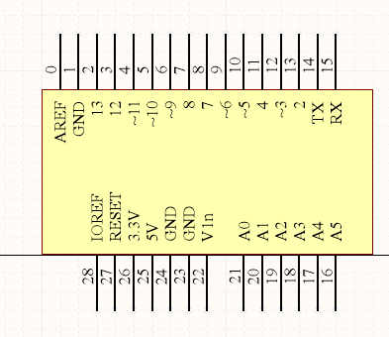
Figure 2 Arduino pin diagram
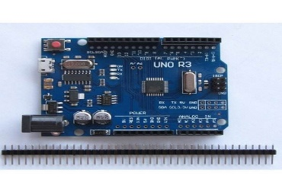
Figure 3 Physical image of Arduino
RDM6300
RDM6300 RDM6300 is a card reader module for 125KHz ID cards. It is used to read EM4100 compatible ID card information. It consists of a C8051F330 and a LM358D dual op amp. Note: EM4100, 4200 cards are read-only. 5557/5567/EM4305 card is set to EM4100 format ID 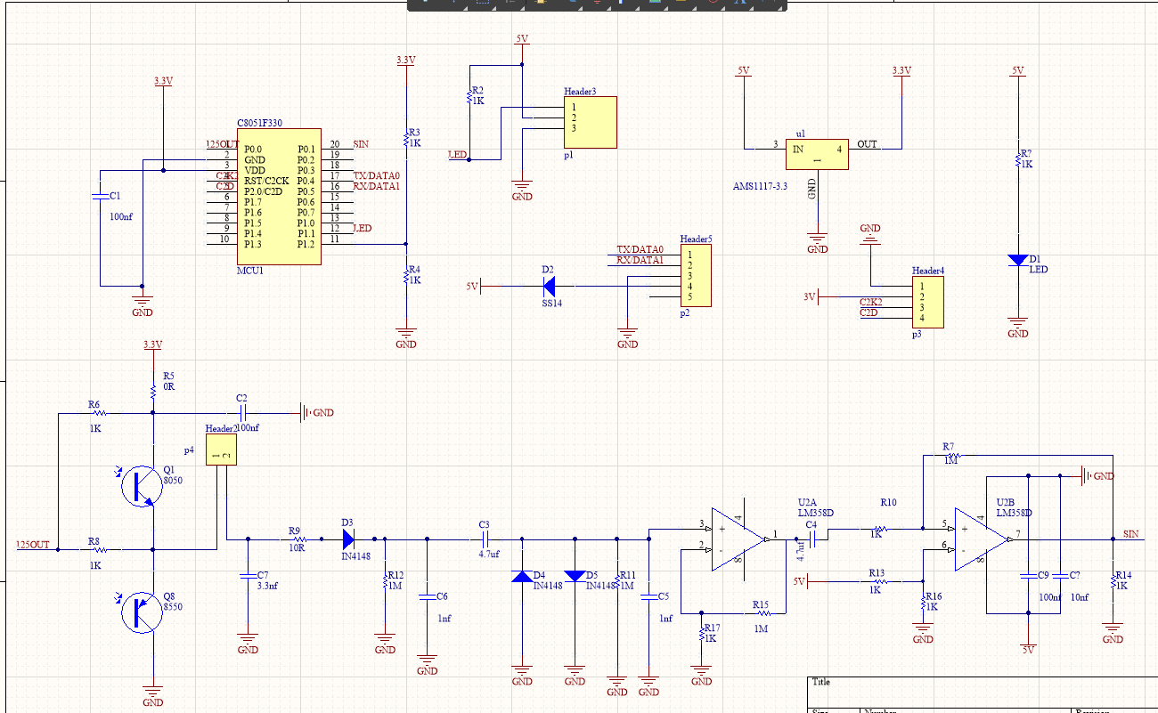
Figure 4 Schematic diagram of RDM6300
Circuit diagram
Draw the circuit diagram as follows
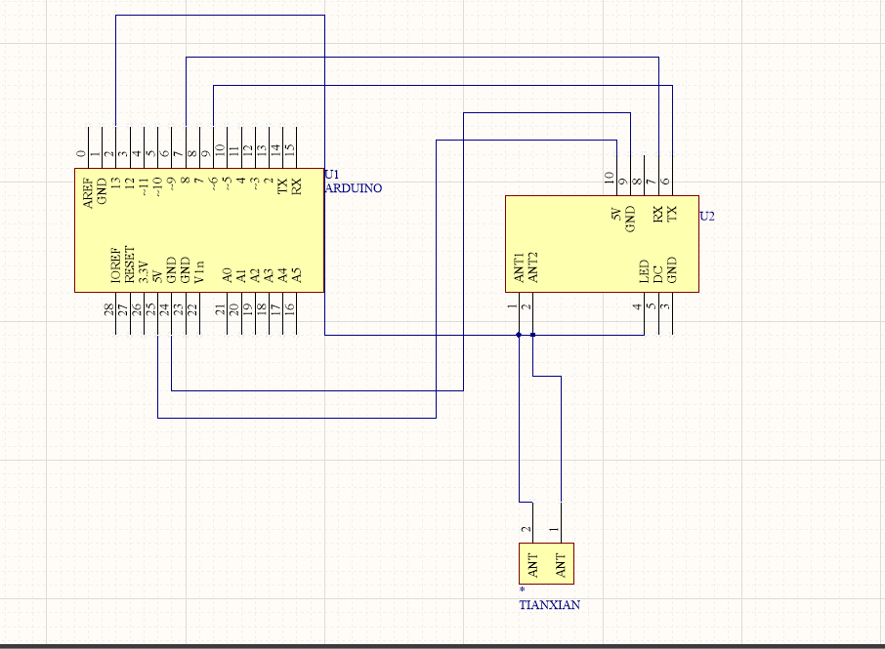
Figure 5 circuit diagram

2. Programming
1  2  3  4  5  6  7  8  9  10  11  12  13  14  15  16  17  18  19  20  21  22  23  24  25  26  27  28  29  30 | #include <SoftwareSerial.h>  #include <RDM6300.h>  SoftwareSerial RFID(6, 8); // RX and TX  int Led=13;  uint8_t Payload[6]; // used for read comparisons  RDM6300 RDM6300(Payload);  void setup()  {  pinMode(Led, OUTPUT);  RFID.begin(9600); // start serial to RFID reader  Serial.begin(9600); // start serial to PC  }  void loop()  {  while (RFID.available() > 0)  {  digitalWrite(Led, HIGH);  uint8_t c = RFID.read();  //Serial.print(c,HEX);  if (RDM6300.decode(c)) {  for (int i=0; i < 5; i++){  Serial.print(Payload[i], HEX);  Serial.print(" ");  }  Serial.println();  }  }  digitalWrite(Led, LOW);  delay(100);  }

六、实验小结 Conclusion
Draw the circuit diagram of RDM6300 with the help of software AD to increase the understanding of RDM6300, and find simpler programming in the open source warehouse of GITHUB to realize the combination of chip and RDM6300.
评语及评分：

